The Country I Live In

1. Pakistan

Pakistan, officially the Islamic Republic of Pakistan, is a country in South Asia. It is the fifth-most populous country, with a population of over 241.5 million, having the second-largest Muslim population as of 2023. Islamabad is the nation's capital, while Karachi is its largest city and financial centre.

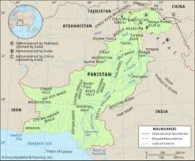

1. Provinces

There are 5 provinces in Pakistan.these are ;

1.Punjab

2.Sindh

3.Khyber Pukhtunkhwa

4.Blochistan

5.Gilgit

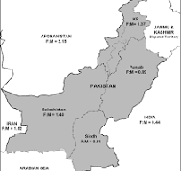

3. culture

The culture of Pakistan (Urdu: پاکستانی ثقافت Pākistāni S̱aqāfat) is based in the Indo-Persian cultural matrix that constitutes a foundation plank of South Asian Muslim identity. The region has formed a distinct cultural unit within the main cultural complex of South Asia, Middle East and Central Asia.

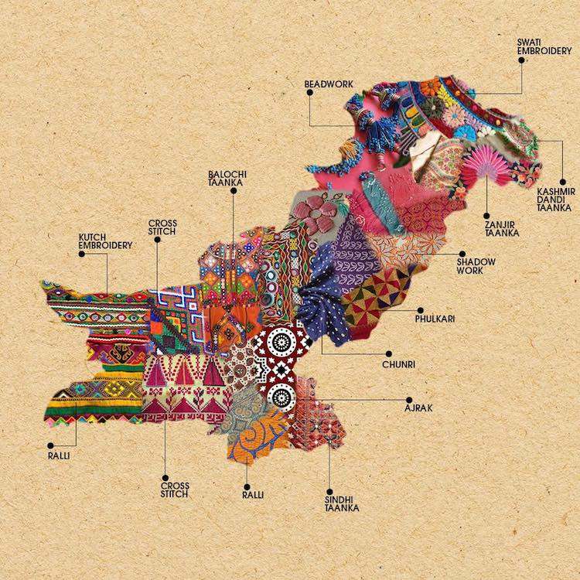

4.food

Pakistani cuisine has Indian roots (found in the form of the usage of heavy spices), Irani influences, Afghani, Persian, and Western influences. Since the Mugal Empire ruled around 1526, Pakistan adopted part of their cuisine that included the herbs and spices, almonds, and the raisins in the country.

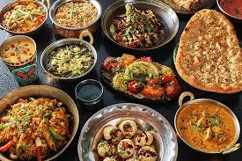

5.dress

The Shalwar kameez, Achkan, Sherwani and Kurta shalwar Kameez are the national dresses of Pakistan and is worn by men and women in all five provinces of Punjab, Sindh, Balochistan, Khyber Pakhtunkhwa, and Gilgit-Baltistan in the country and in Azad Kashmir. Shalwar refers to loose trousers and kameez refers to shirts.

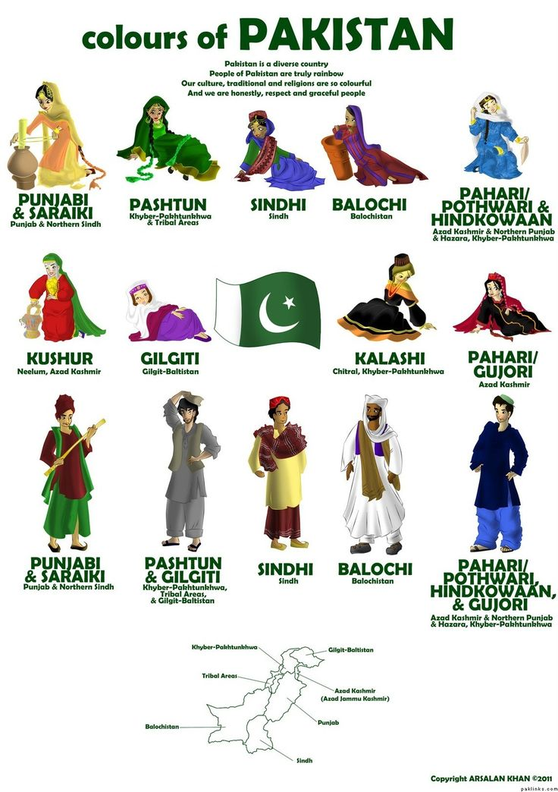

a table descreption on provinces and their area

|  |  |
| --- | --- |
| provinces | area |
| punjab | 205,344 km² |
| sindh | 140,914 km² |
| khyber pukhtunkhwa | 74,521 km² |
| blochistan | 347,190 km² |
| gilgit | 72,971 km²- |